Slicing Strings

## **Slicing**

You can return a range of characters by using the slice syntax.

Specify the start index and the end index, separated by a colon, to return a part of the string.

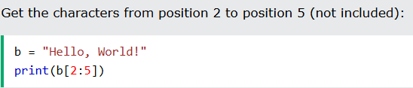

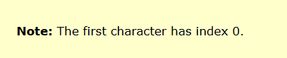

## **Slice From the Start**

By leaving out the start index, the range will start at the first character:

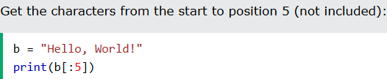

## **Slice To the End**

By leaving out the end index, the range will go to the end:

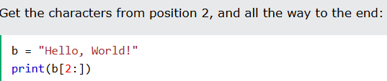

## **Negative Indexing**

Use negative indexes to start the slice from the end of the string:

